Demo on Streaming Data & Structured Streaming
What is Databricks?
DataBricks is a cloud-based platform built on Apache Spark that simplifies:
- Data Engineering
- Data Analytics
- Machine Learning
- Data Warehousing
And it does provide:
- Interactive Notebooks
- Managed Spark Clusters
- Collaboration Features
- Built-in Security & Governance
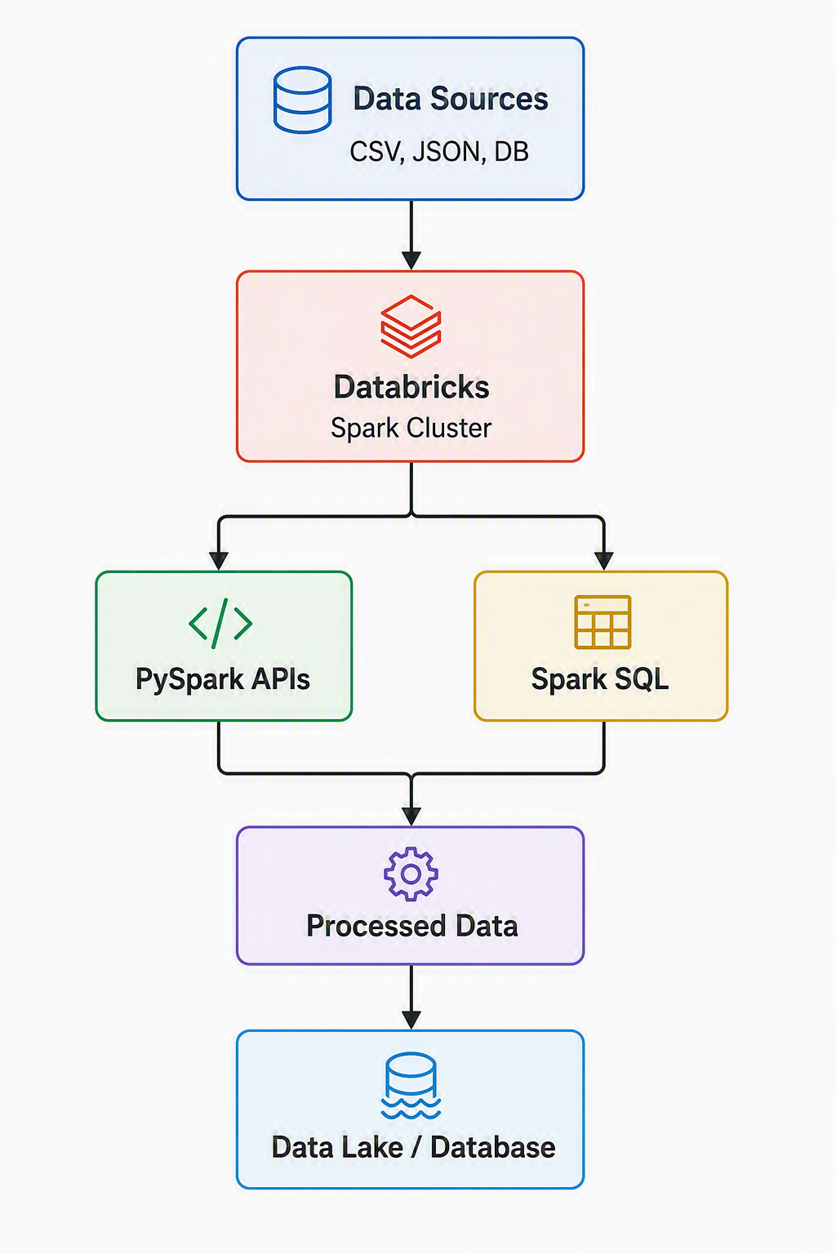

Create Free Databricks Community Edition Account
Create a Cluster
Create a Notebook
Verify Spark Session
Create Your First DataFrame

Capstone ETL Project: Retail Data Engineering Pipeline Using PySpark
Problem Statement
A leading retail organization collects business data from multiple sources, including customer information, product catalogs, and sales transaction records. Due to the growing volume of data, the organization faces challenges in consolidating, cleansing, analyzing, and generating actionable business insights in a scalable manner.
As a Data Engineer, you are required to design and implement an end-to-end ETL (Extract, Transform, Load) pipeline using PySpark on Databricks that processes retail data efficiently and supports analytical reporting and business decision-making.
The solution should leverage PySpark's distributed processing capabilities to ingest data from multiple files, perform data quality checks and business transformations, generate key performance indicators (KPIs), and optimize processing performance for large-scale datasets.

Business Objective
Develop a scalable Retail Data Engineering Pipeline that enables the organization to:
- Consolidate customer, product, and transaction data.
- Improve data quality through cleansing and validation.
- Apply business rules to derive meaningful business metrics.
- Generate retail KPIs and management reports.
- Optimize data processing using Spark performance tuning techniques.

Data Sources
1. Customer Data
Contains customer-related information such as:
- Customer ID
- Customer Name
- Gender
- Age
- City
- Registration Date
2. Product Data
Contains product master information such as:
- Product ID
- Product Name
- Category
- Brand
- Unit Price
3. Sales Transaction Data
Contains transactional records such as:
- Transaction ID
- Customer ID
- Product ID
- Quantity Sold
- Transaction Date
- Sales Amount

Project Requirements
Phase 1: Ingestion Layer
Objective
Extract data from multiple source files into Spark DataFrames.
Tasks
- Read Customer, Product, and Sales files from source storage.
- Handle CSV, JSON, or Parquet formats.
- Infer schema and validate data structure.
- Load data into PySpark DataFrames.
Expected Output
- Customer DataFrame
- Product DataFrame
- Sales Transaction DataFrame

Phase 2: Transformation Layer
Objective
Prepare data for analytics by applying cleansing and business logic.
Data Cleaning Tasks
- Remove duplicate records.
- Handle missing/null values.
- Validate data types.
- Standardize column names.
- Remove invalid transactions.
Business Rule Implementation
- Calculate Total Revenue
Revenue = Quantity × Unit Price
- Identify High-Value Customers.
- Categorize Products by Revenue Contribution.
- Generate Customer Purchase Frequency.
- Calculate Monthly and Category-wise Sales.
Data Integration
Perform joins between:
Customer Data
Product Data
Sales Transactions
to create a consolidated retail dataset.

Aggregations
Generate:
- Sales by Product Category
- Sales by Region/City
- Customer-wise Revenue
- Monthly Revenue Trends
- Top-Selling Products

Phase 3: Analytical Layer
Objective
Generate meaningful business insights and KPI reports.
Key Performance Indicators (KPIs)
Sales KPIs
- Total Revenue
- Total Orders
- Average Order Value (AOV)
- Monthly Sales Growth %
Customer KPIs
- Total Customers
- Active Customers
- Repeat Customers
- Top 10 Customers by Revenue
Product KPIs
- Best-Selling Products
- Revenue by Category
- Product Performance Ranking

Reports
Generate analytical reports such as:
- Top 10 Products by Revenue
- Top 10 Customers by Sales
- Monthly Sales Trend Report
- Category Performance Report
- City-wise Revenue Report

Phase 4: Optimization Layer
Objective
Improve pipeline performance for large-scale data processing.
Optimization Techniques
Partitioning
Partition datasets based on:
Transaction Year
Transaction Month
Product Category
Benefits:
- Faster query execution
- Reduced I/O operations
- Improved scalability
Caching
Cache frequently accessed DataFrames:
Customer Master
Product Master
Aggregated Sales Dataset

Benefits:
- Faster repeated computations
- Reduced processing time
- Improved Spark performance

Expected Deliverables
ETL Pipeline
- Automated PySpark ETL workflow
- Reusable and modular code
Processed Data
- Cleaned Retail Dataset
- Aggregated Data Mart
Analytical Outputs
- KPI Dashboard Dataset
- Business Reports
Performance Optimization
- Partitioned output files
- Cached Spark DataFrames
- Optimized execution plan

Success Criteria
- The project will be considered successful if:
- Data from multiple sources is successfully ingested into PySpark DataFrames.
- Data quality issues are identified and resolved.
- Business rules and transformations are correctly implemented.
- KPIs and analytical reports are generated accurately.
- Spark optimization techniques such as partitioning and caching are effectively applied.
- The solution can process large retail datasets efficiently in a Databricks environment.
End Goal
Build a production-ready Retail Data Engineering Pipeline using PySpark and Databricks that transforms raw retail data into actionable business insights while demonstrating core Data Engineering concepts including ETL processing, data modelling, analytics, and Spark performance optimization.

